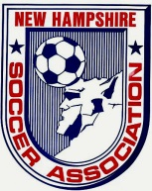
New Hampshire Soccer Association
November 2013 Board Meeting Minutes

Attendees: Bob Willey, candia campbell, Mark Chagnon, Cory Halvorsen, Bill Thornton, Mark Sadler, Tom Haydock, Carla Nastri, & Ric Marion

Meeting called to order at: 6:35PM

Secretary Report: Written report attached. candia campbell made a motion to accept the minutes. Bill Thornton seconded it. Minutes accepted.

Treasurers Report: Written report attached. Bill Thornton moves to accept the Treasurers report for audit, Carla Nastri seconded it.

President’s Report: Written report attached.

Executive VP: Written report attached.

Recreation VP: Written report attached.

Competitive VP: Written report attached.

Adult VP: Written report attached. Cory and Mark will be meeting to discuss a women’s 6v6 league for late spring, summer and early fall.

State Coach of Education: Written report attached.

State Coach of ODP: Written report attached.

State Referee: Committee: No written report attached. Verbal by Mark Sadler. Referee training is starting up now that the fall season is over.

State Administrator: Written report attached.

State Registrar: Written report attached.

Risk Management: Written report attached.

VP Indoor: No written report attached.

NHSL: Written report attached.

TOPSoccer: No written report attached.

Ongoing Business

Breakers Partnership: Bill Thornton made a motion to renew partnership with Boston Breakers at a cost of $1,200.00 Mark Chagnon seconded it. Motion passed.

AGM: Mark is working with Athletic Director at SNHU to reserve the space needed for the AGM. NHSA sponsors will participate in the AGM – including NE Revs, TD Bank, Got Soccer, Admiral.

NHSL: Report attached

New Business

Nomination Committee: Bill Thornton is the Nominations Committee Chair.

By-Laws Committee: Carla Nastri is By-Laws Committee Chair.

Good of the Game
Craig Tornburg is now the General Manager & Director of Global Business of the Oxford City club in England gives his best wishes to NHSA and to NWC for putting on a wonderful tournament.

Next Board Meeting: Tuesday, December 10th, 2013.

Meeting adjourned at

Respectfully Submitted,
Carla Nastri
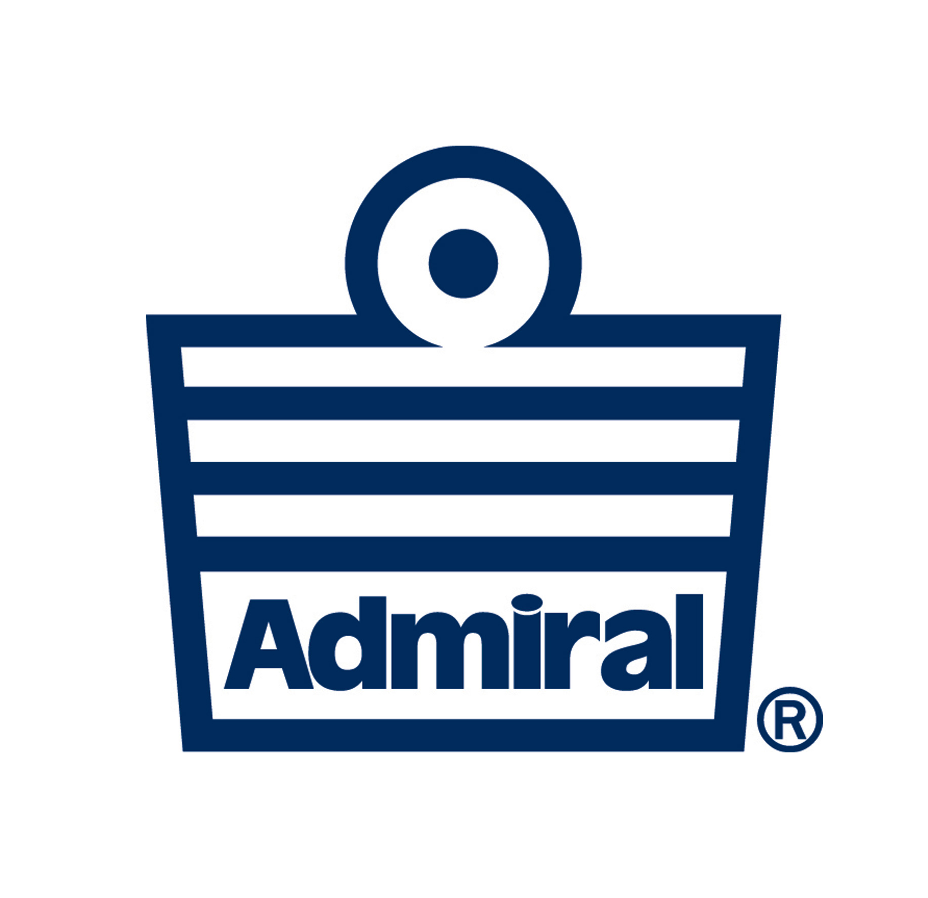
NHSA Secretary

